**//Using FileReader and FileWriter**

**FileManager.java**

package consoleIOPrograms;

import java.io.*;

public class FileManager {

public boolean writeToFile(String fileName, String data)

{

try{

File file = new File(fileName);

if(file.exists())

{

FileWriter fileWriter = new FileWriter(file,true);

fileWriter.write(data);

fileWriter.close();

return true;

}

else

{

file.createNewFile();

return writeToFile(fileName,data);

}

}catch(Exception ex){

return false;

}

}

}

package consoleIOPrograms;

public **class Test** {

public static void main(String[] felight)

{

FileManager fileManager = new FileManager();

fileManager.writeToFile("D:\\Console\\Hello.txt", "hello");

}

}

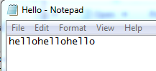

public **void readFromFile**(String fileName)

{

try{

File file = new File(fileName);

if(file.exists())

{

char[] data = new char[2000];

FileReader fileReader = new FileReader(file);

fileReader.read(data);

System.out.println(data);

}

else

{

System.out.println( "File not found");

}

}catch (Exception ex)

{

System.out.println(ex);

}

}

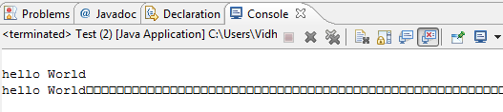

public **void bufferReaderExample**(String fileName)

{

try{

File file = new File(fileName);

if(file.exists())

{

FileReader fileReader = new FileReader(file);

BufferedReader bufferedreader = new BufferedReader(fileReader);

StringBuilder data = new StringBuilder();

while(true)

{

String currentLine = bufferedreader.readLine();

if(currentLine == null)

break;

data.append(currentLine+"\n");

}

System.out.println(data.toString());

}else{

System.out.println( "File not found");

}

}catch (Exception ex)

{

System.out.println("null");

}

}